Employee registration Portal

Technologies Used - Spring Boot, react Js

Tools Used – IntelliJ, Visual Studio code

Source Control – Git, GitHub

Database – H2

This application is built on Spring Boot and React JS and data base used is h2

UI is accessible on Port http://localhost:3000

H2 console on: <http://localhost:8080/h2-console>

For Registration required field is 1. First Name

2. Last Name

3. Email

4. Date of Birth

5. Username

6. Password

For Username and Password there are some restrictions that can be done on backend side

For Password there is encryption and decryption method AES algorithm is used

For UI I have Installed Library like

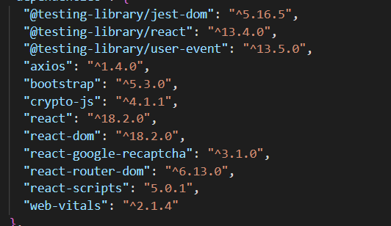

For Backend Dependency used

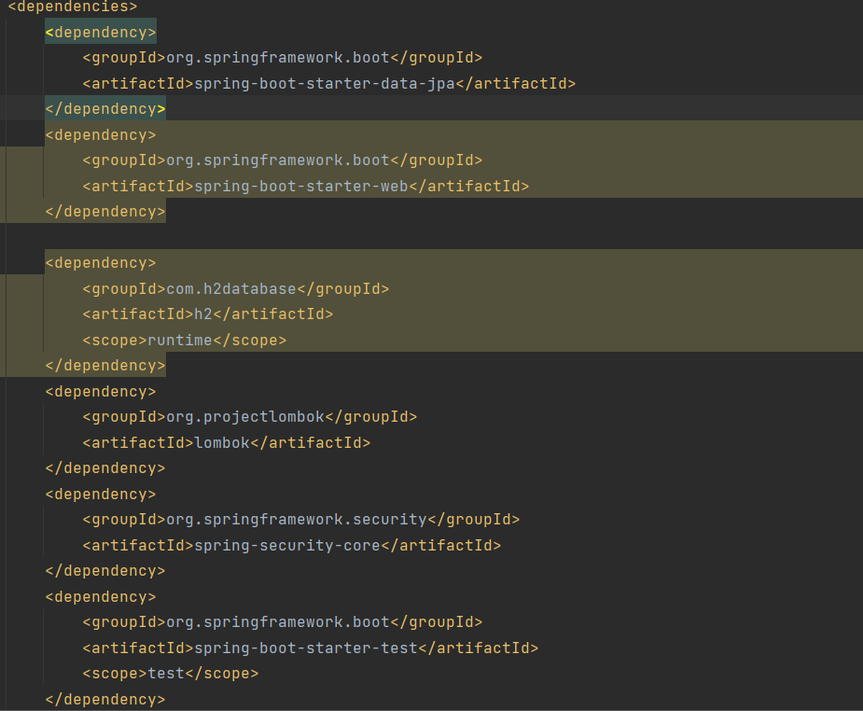

For Login only required

1. Username
2. Password

Once Successfully Login It will redirect to Home Page